Using Controller Buttons

# **Description**

This tutorial is a guide for using controller buttons

# **Instructions**

1. Look on the desktop for the Robot C icon. Select the “RobotC for Vex Robotics”  
   Do not open the “Graphical ROBOTC” program  
   1. 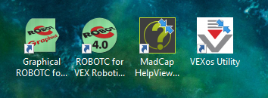
2. Open a new file and enter the following  
   1. 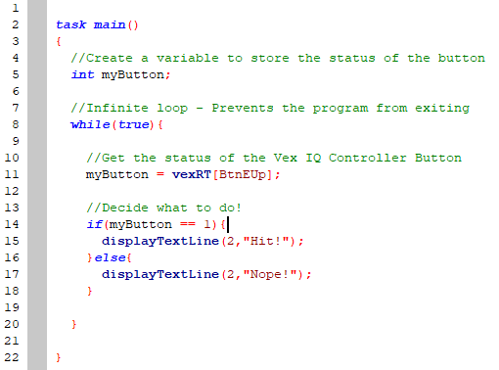
3. Compile, Download to Robot, and Start  
   1.  🡪  🡪 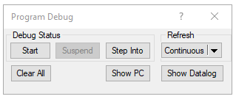
4. Test out the E-Up button!
5. Try changing the button “BtnEUp” to a different button. Use the images below as a guide!

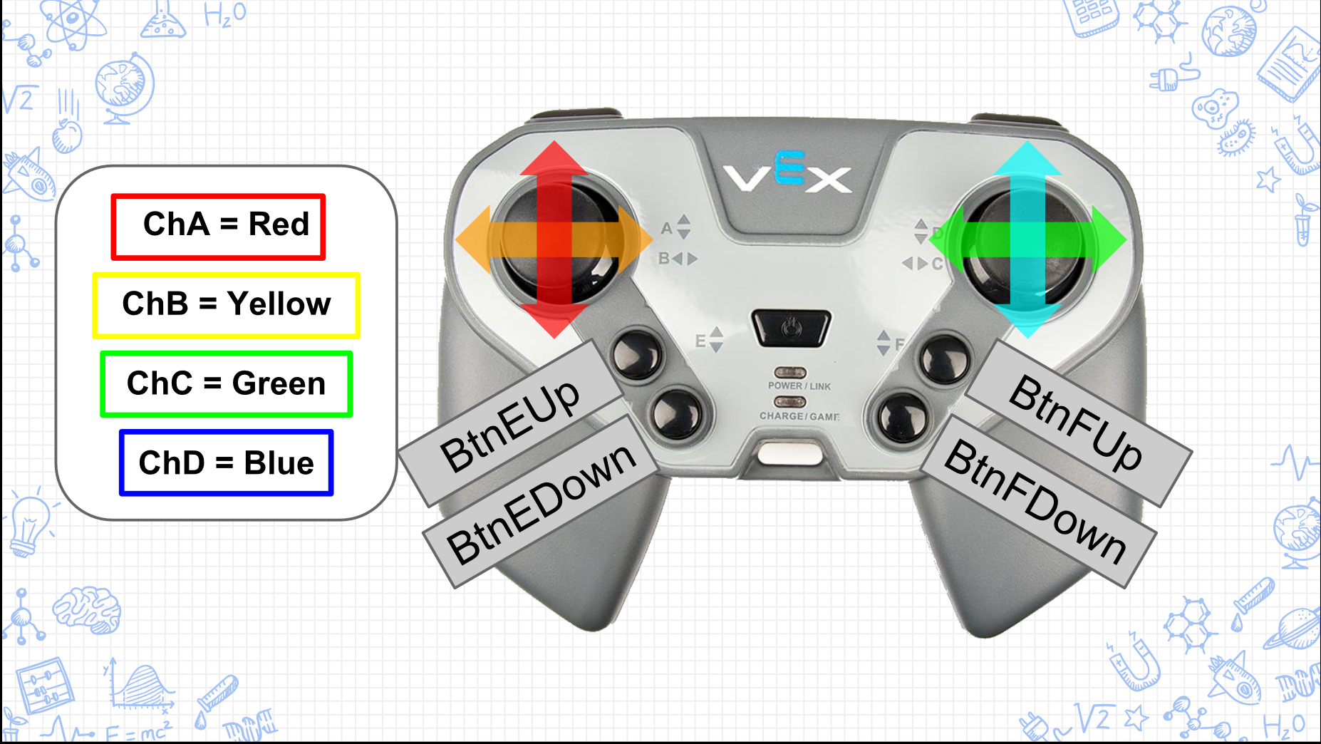  
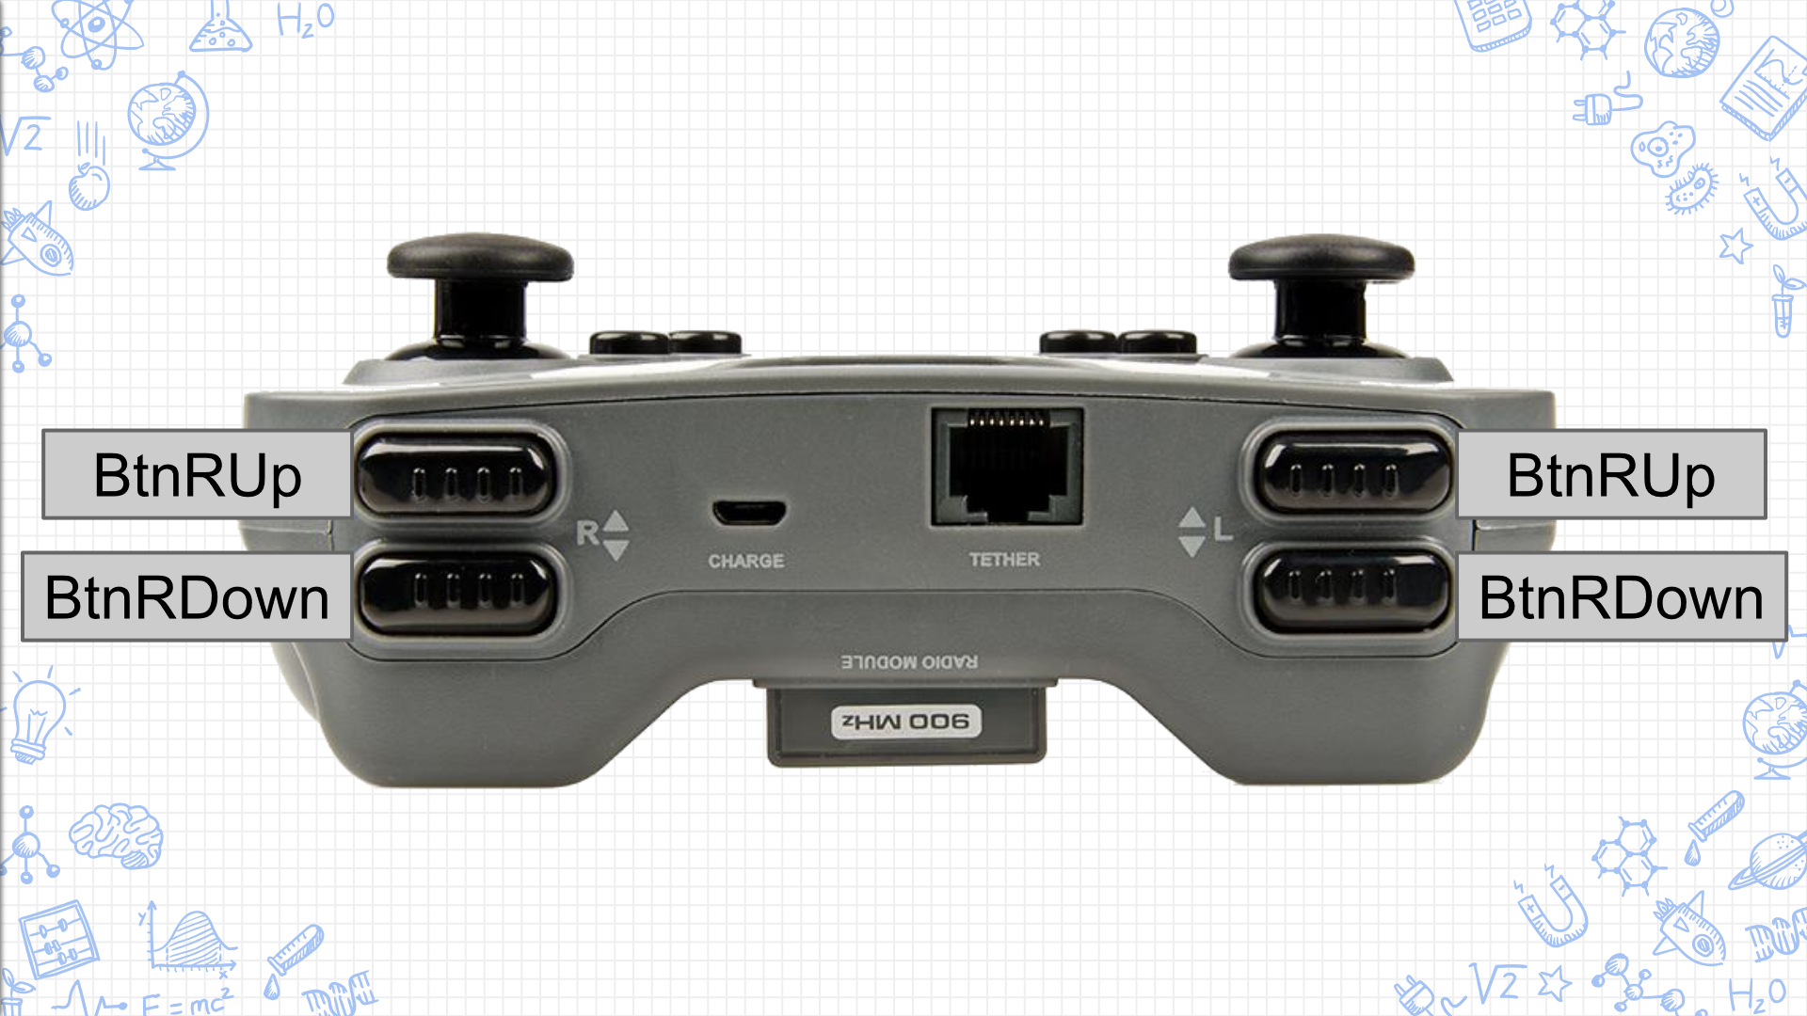

1. Try adding a second button!
   1. Add another global variable
   2. Fill the additional variable with a different VexRT[] button
   3. Use an if-else statement to print a new phrase on a **different line**